Dear Parents/Carers
We hope you have all been well over the closure due to the Pandemic. Its been a very unusual time for us all.
From previous conversations you are aware that unfortunately we had to give notice on the hire of Wallheath Scout Hut and that we made provision at our day nursery setting to accommodate our before and after school club. As promised and I know it is delayed, I have provided pictures of new setup. Please share the photographs with your child/ren.
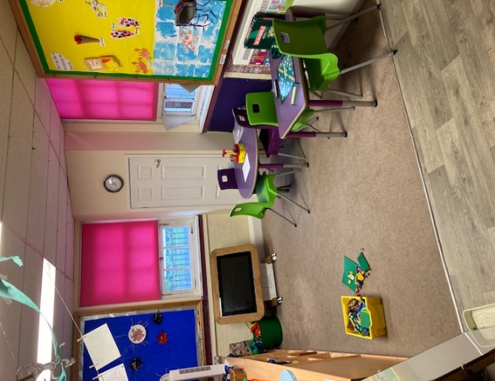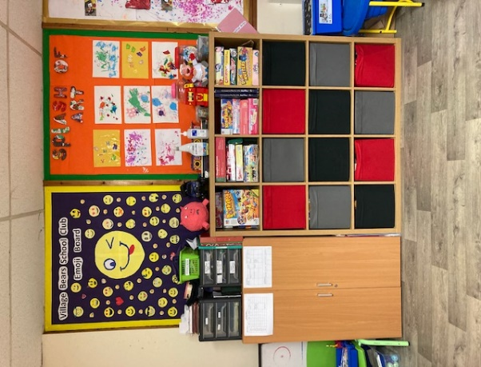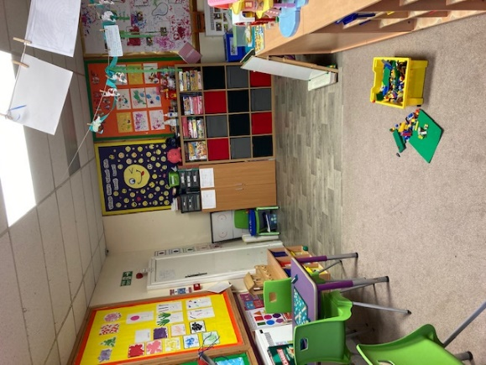
It is a cosy space, we intend to use the outdoors more. We aim to access Wallheath Park/field daily (weather permitting) on our afternoon session. We have updated the routine to include a time slot when we access park /field (3.45pm-4.30pm). This has yet to be trialled as we need to assess how long it takes to collect children and register them before we make our way to park/field. If time has to be adjusted we will let you know. The activities we provide and staff will not change. It is only the location where we function from.
As we reopen to all children from Thursday 3rd September, the routine for drop off and collection will be different. We will follow the school operation plan for arrival and dismissal.
Morning Club- Staff member will drop your child/ren off at appropriate gate for their class as identified by school.
Afternoon session- Staff member will collect from designated dismissal point identified by the school.
Before Covid after school club met in the the library area but this will not be possible, so please share with your child/ren that we will be outside in the designated collection pointas highlighted by the school. All class teachers will have a list of what children in their class attend club on what sessions/days.
Social distancing will be promoted within the group. We are only a small group so we will remain as one group but will social distance from other groups based in the nursery setting.
There is a risk asssessment on our website, please take a look and if you have any questions please get in touch.
The room children are based in & resources will be cleaned after every session. Handwashing will be actively encouraged; on arrival to club, after outdoor play, before & after meals etc. We also have hand sanitizer available. Currently parents are not permitted in the setting so you will drop off and collect your child/ren from main entrance door. You will be greeted by a member of staff based in school club. We will request approximate times for drop off and collection to enable us to monitor socially distancing outside the setting.
Can I take this opoortunity to thank you all for your kind words and support over the last 5 months and we are looking forward to welcoming your children back to school club. Please contact us if you have any questions regarding your child’s return to club either by email or phone.

Kind Regards

Clare

